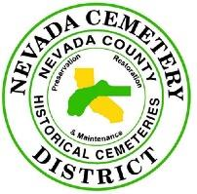

Nevada Cemetery District

P.O. Box 2400

10523 Willow Valley Road

Nevada City, Calif 95959

Phone 530-265-3461

**PUBLIC NOTICE**

of the

**NEVADA CEMETERY DISTRICT**

of a

**SPECIAL MEETING**

of the

**BOARD OF TRUSTEES**

of

**Friday, August 9, 2024, at 2:00 PM**

at the  
**Nevada Cemetery District**

Please note time and meeting place above.

**AGENDA**

BOARD CALL TO ORDER - PUBLIC SESSION

ROLL CALL • Trustee Bushore

• Trustee Hurst

• Trustee Ward

PUBLIC COMMENT ON MATTERS ON THE AGENDA:

This is the time for any member of the public to address the Nevada Cemetery Board of Trustees as to any item on the agenda. Comment on items not on the agenda is welcome at regular meetings of the Board, but not at special meetings.

ADJOURN TO CLOSED SESSION.

1. AGENDA

A. PUBLIC EMPLOYMENT (Govt. Code Section 54957)

Title: General Manager

**B.** ADJOURNMENT OF CLOSED SESSION.

II. REOPEN PUBLIC SESSION

1. Summation of any Closed Session action by the Board
2. ADJOURNMENT OF OPEN SESSION

ATTEST:

GERALD R. BUSHORE, BOARD CHAIR

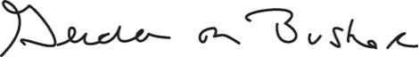e

page2image37304000

THIS AGENDA WAS POSTED August 7, 2024, ON:

• THE NEVADA CEMETERY DISTRICT WEBSITE

• THE ROOD GOVERNMENT CENTER, MAIN LOBBY BULLETIN BOARD

• THE NEVADA CEMETERY DISTRICT EXTERIOR ENTRY DOOR BULLETIN BOARD